**Week 6 Solutions**

**React**

1. **ReactJS-HOL** .

Create a react app for Student Management Portal named studentapp and create a component

The code and the folder structure is attached in the **Week 6/2 reactjs HOL/studentapp**  folder

**Output :-**

**Chrome – http://localhost:3000/**

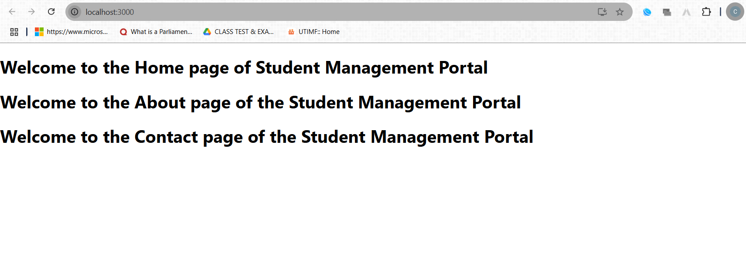

**The hands on file and folder is attached along with it**